Week#14 Logging & Recovery in SQLite

Hyuksoo Yeo

2016312761

# INTRODUCTION

Run TPC-C benchmark for two journal modes, delete mode and wal mode. Then observe how TPS (txn/s) changes. Record and analyze the TPS for each transaction type such as DELIVERY, NEW_ORDER, ORDER_STATUS, PAYMENT, STOCK_LEVEL. Then present and analyze the experimental results. I will explain the root cause of the performance gap between delete mode and wal mode.

# METHODS

For this experiment, we should prepare setup like week13 experiment. Same as last experiment, loading database with 10 warehouses, and run TPC-C benchmark. In this week, we should input ‘–journal’ in running command to change journal mode. Repeating running after change journal mode from del to wal.

# Performance Evaluation

## Experimental Setup

System setup:

|  |  |
| --- | --- |
| Type | Specification |
| OS | Ubuntu 20.04.3 LTS |
| CPU | Intel® Core™ i3-9100F CPU @ 3.60GHz |
| Memory | 16GB |
| Kernel | 5.11.0-27-generic |
| Data Device | Western Digital WD Blue 500GB |
| Log Device | Western Digital WD Blue 500GB |

Benchmark setup:

|  |  |
| --- | --- |
| Type | Configuration |
| DB size | 1GB (10 warehouse) |
| Buffer Pool Size | 300MB (30% of DB size) |
| Benchmark Tool | tpcc-mysql |
| Runtime | 1200s |
| Connections | 8 |

## Experimental Results

Journal mode = wal

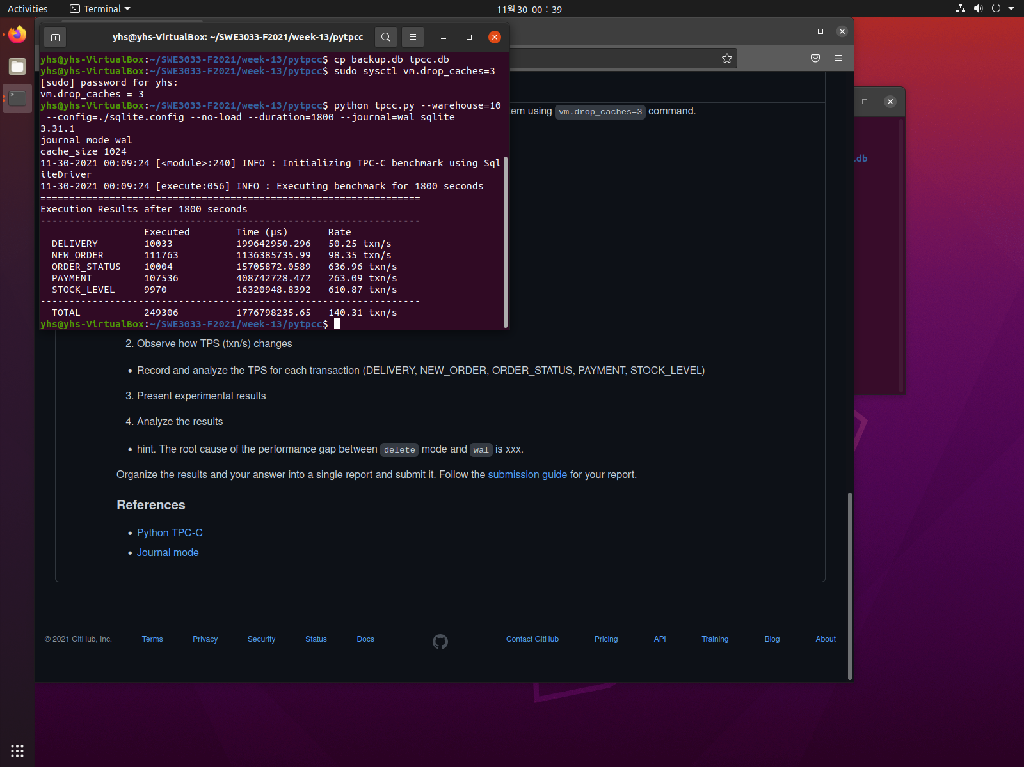

Journal mode = del

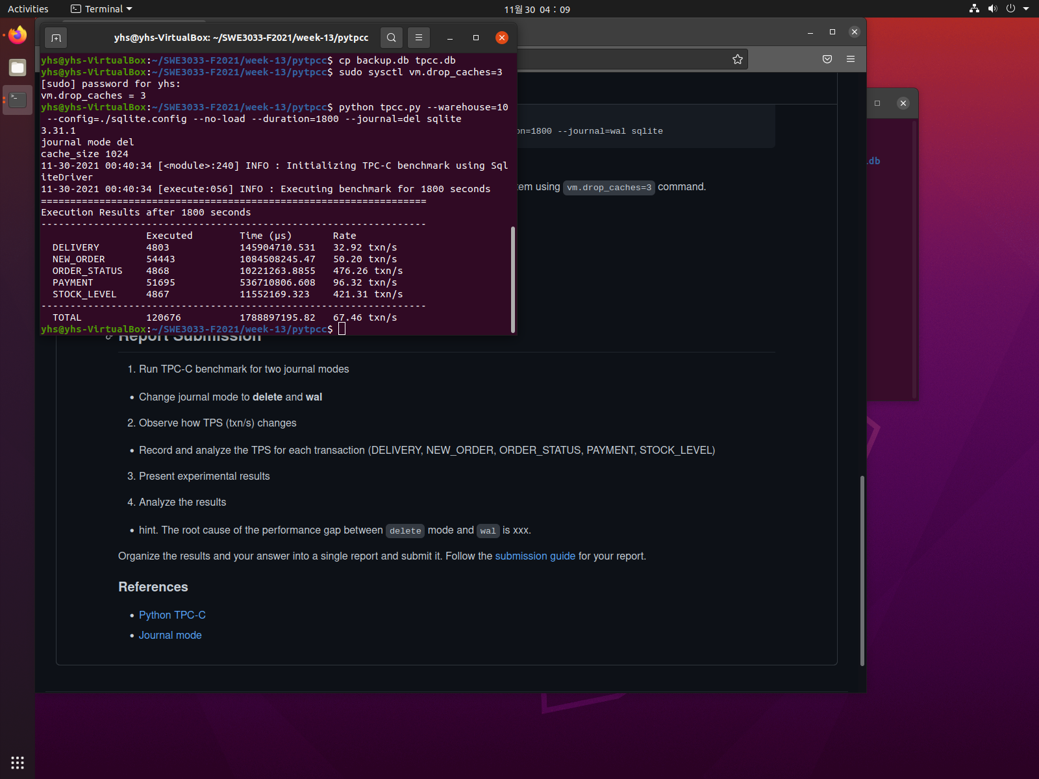

The total TPS is 140.31, and 67.46 txn/s each. Wal journal mode shows much more higher performance than del mode. It is because write ahead logging is significantly faster in most scenarios. Disk I/O operations tends to be more sequential when using WAL mode. Because WAL uses fewer fsync() operations in transaction. While deleting file uses fsync() in flushing RBJ. Deleting file is expensive.

# Conclusion

In this experiment, I learned how to evaluate performance between two journal mode (RBJ and WAL) on SQLite database engine using TPC-C benchmark. (pytpcc). Wal mode is much faster than del mode in SQLite.

# REFERENCES

[1] [https://github.com/meeeejin/SWE3033-F2021/tree/main/week-1](https://github.com/meeeejin/SWE3033-F2021/tree/main/week-10)4